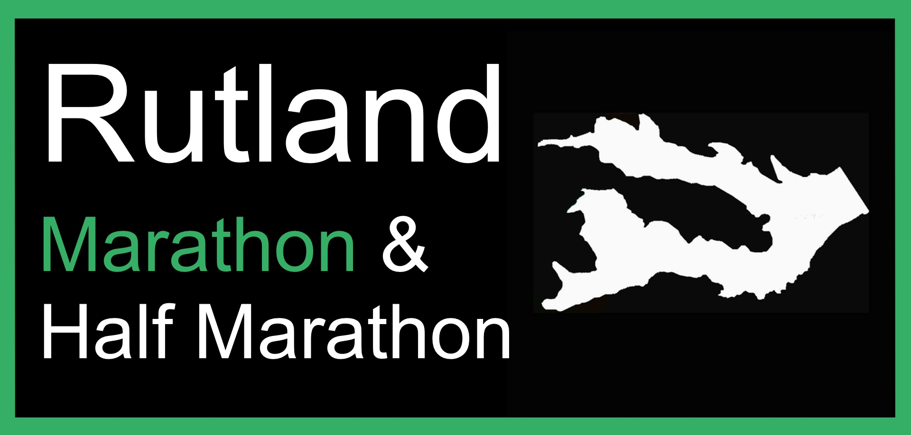

Refund Policy 2022

This policy is final and not dependant on circumstance.

- Until 5 months prior to race day – 25th April 2022, 50% refund on entry fee
- Until 3 months prior to race day – 25th June 2022, 25% refund on entry fee
- After 3 months prior to race day – 26th June 2022, No refunds given

We have a clear policy on refunds to remain fair to competitors. In previous years, we had a no refund policy from the point of entry. Our amended policy reflects an acknowledgement that circumstances arise beyond our participants control. The clear cut off dates acknowledge the ongoing investment made by the organisers in regard to your entry. As a result, exceptions cannot be made to this policy.

Transferal of Entries Policy 2022

Entries may be transferred to another runner up until and including 14th August 2022. There will be no transferal of details after this point.
The Rutland Marathon & Half Marathon will deal with the changes of details but play no part in any financial transfers between participants.

Entries may also be transferred to another of our events including the Rutland Marathon & Half Marathon 2023 up until and including 31th July 2022.

Please note we do not advertise unwanted race entries.

Event Cancellation

If the event is cancelled by the organisers, runners will automatically be deferred into the following year’s event.

